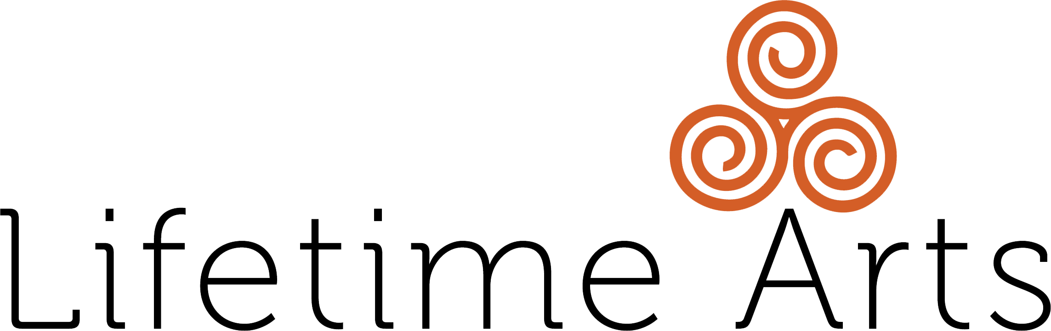

In-Person Creative Aging Program Curriculum Outline

Program Title: Big Idea:
Describe your overall goal for the program in one sentence:

Learning Goals:
Identify the learning goals for the program. What will participants be able to know and/or do? Include arts techniques that participants will be learning, as well as completed project and social engagement goals.
Participants will:

●
●
●
●
●

Program Description:
Provide a one paragraph program description. Include details about the themes/topics and art skills that will be taught, and community engagement benefits. This description may be used to market the program.

Reminder: The Nevada Arts Council Creative Aging Pilots must have a minimum of 4 sessions plus a culminating event.

Culminating Event Description:
Describe the culminating event. Include details about the goals, social engagement opportunities for audience and students, and overall vision for the final sharing. This description may be used to market the culminating event.

Session Outlines:
Brief Description of Class Plans:
Social Engagement Goal:
Skill Building Goal:
Session 1 Title:

Brief Description of Class Plans:
Social Engagement Goal:
Skill Building Goal:
Session 2 Title:
Session 3 Title:

Social Engagement Goal:

Brief Description of Class Plans:

Brief Description of Class Plans:
Social Engagement Goal:
Skill Building Goal:
Session 4 Title:

Session 5 Title: (Culminating Event)

Social Engagement Goal:

Brief Description of Event Plan:

Additional Sessions, if needed:
Brief Description of Event Plan:
Social Engagement Goal:
Skill Building Goal:
Session 6 Title:
Session 7 Title:

Social Engagement Goal:

Brief Description of Event Plan:

Brief Description of Event Plan:
Social Engagement Goal:
Skill Building Goal:
Session 8 Title:

